STATIONS OF THE CROSS

The tradition of stations of the cross began as the church grew from Jerusalem to other areas of the world. Tradition dictated that Christians should walk the final walk of Christ to his crucifixion on Calvary. The route is called Via Dolorosa, which means way of sorrow or pain. As the church spread through the world and people could not make the journey to Jerusalem, churches began having stations of the cross placed inside so that the faithful could make this “walk” with Christ and stop 14 times remembering Christ’s passion. Today, here at Salve, we make our walk with Christ.

At each station we will stop and remember a particular moment on Christ’s last walk. At each station we will also remember a current event or concern looking through Christ’s eyes as we accompany him today. We ask you to reflect on what you see and hear as we walk along. The passion of Christ today.

First station
JESUS IS CONDEMNED TO DEATH
We adore You, O Christ, and we bless You.
Because by your holy Cross You have redeemed the world.

Jesus, stood before Pilate, accused of asking us to love God and each other, for that he was put to death. How do we respond to that commandment of Jesus to love one another? What must I do?

Prayer
All-powerful and eternal God, for proclaiming the truth, your Son, Jesus Christ, is condemned to death by crucifixion. Stir up your love in our
hearts so that we might be ever faithful to all that You have told us and
fear nothing more than the loss of your friendship through sin. Amen.

Second station
JESUS IS MADE TO CARRY THE CROSS
We adore You, O Christ, and we bless You.
Because by your holy Cross You have redeemed the world.

Miley Hall
As we stand before this dining hall we remember those who do not have enough food to sustain their life. Those who each day suffer and die for lack of nourishment. In a world of plenty there is much want. Look at world hunger through the eyes of Jesus. See their faces. They are among us. What must I do?
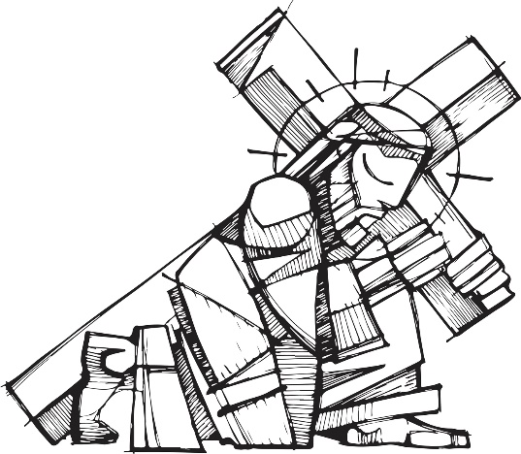
Prayer
Father in heaven, your Son, Jesus Christ, still carries his Cross in his
persecuted brothers and sisters throughout the world. Make us feel the
needs of all persons so that we might as readily help them as we would
help Jesus himself. Amen
Third station
JESUS FALLS THE FIRST TIME
We adore You, O Christ, and we bless You.
Because by your holy Cross You have redeemed the world.

Gerety Hall
The magnificence and beauty of this building stands before us. Remember those who labored to build it. The immigrants who built these palaces of luxury and lived in poverty. Remember the undocumented immigrants today that labor and live in fear of deportation, family separation, poverty. What must I do?

Prayer
O God, to free us from sin and weakness your Son, Jesus Christ, embraced his fearful passion and crucifixion. Strengthen us to our baptismal resolutions by which we renounced sin and Satan, so that through the passion of this life's sufferings we might rise to a new life of joyful service free of all selfishness. Amen.

Fourth station
JESUS MEETS HIS MOTHER
We adore You, O Christ, and we bless You.
Because by your holy Cross You have redeemed the world.

Sunken Garden
A place of reflection, peace and contemplation. Think of your mother, think of her joys and sorrows. Think of mothers separated from their children at the border. Mothers who have to send their children on the journey to this country alone because of their love for them and the promise of a better life. What must I do?
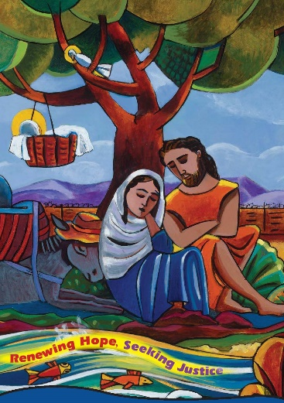
Prayer
O blessed Lord, at your passion a sword of sorrow pierced the loving heart of your mother as Simeon had foretold. Grant that we who look
back on her sorrows with compassion might receive the healing fruits of
your sufferings. Amen.

Fifth Station
SIMON OF CYRENE HELPS JESUS CARRY HIS CROSS
We adore You, O Christ, and we bless You.
Because by your holy Cross You have redeemed the world.

Learn, Lead, Make a Difference
A command? A path? Putting our faith into action? A Mercy request from Catherine McAuley? I’m learning, how do I lead to make a difference? Simon is pressed into service to aid Jesus. How does he feel? Fearful, willing, resentful, compassion for this man? How do I feel as I look around? Do I see what is before me? Do I look away? How do I lead? How do I make a difference? Lift someone up. What must I do?

Prayer
Lord Jesus Christ, help us to see in the sufferings and shortcomings of our lives a share in Your Cross; strengthen and console us in the belief that
we bear all things in union with You, who have taken upon Yourself even our guilt. Amen.

Sixth Station
VERONICA WIPES THE FACE OF JESUS
We adore You, O Christ, and we bless You.
Because by your holy Cross You have redeemed the world.

McKillop Library
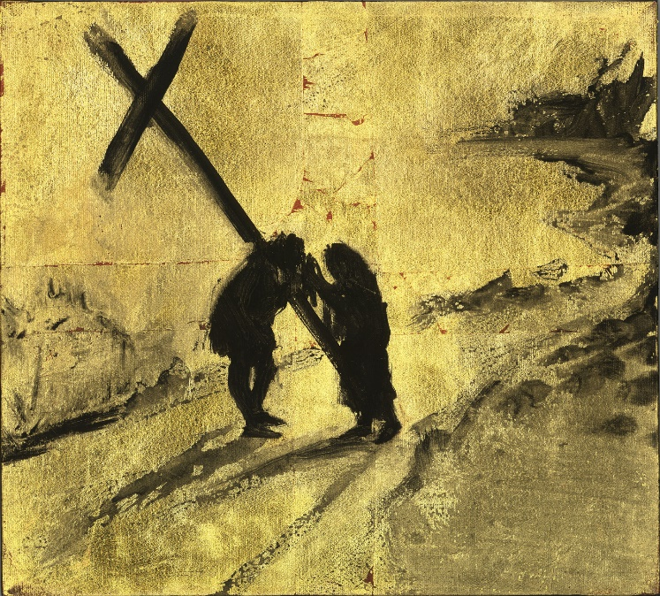
Learning, knowledge, compassion. Oppression, racism, ignorance, illiteracy. This place represents the power of knowledge good and bad. Do I step from the crowd to wipe the face of the oppressed? Prejudice, hatred, racism, oppression, ignorance, illiteracy. These are all contrary to our faith, our call to love and compassion. The example of Veronica tells us to step from the crowd to touch the poor with our hands, our love. What must I do?
Prayer
Almighty and ever-loving God, we feel your love and understanding in the consolation and support we receive from one another. Give us, we beg You, the courage and dedication to sacrifice and suffer with those who are in need, the least of your people. Amen.

Seventh Station
JESUS FALLS THE SECOND TIME
We adore You, O Christ, and we bless You.
Because by your holy Cross You have redeemed the world.

Labyrinth
A challenge to arrive at the center, a time of thought, and prayer. What am I led to? A feeling of accomplishment at the center? Or the challenge to help? I have everything in me to pick Jesus up and set him on his feet. I have everything in me to live my life nonviolently not contributing to the violence that is in our lives. I can forgive, I can raise people up. I can live in peace. What must I do?

Prayer
Lord Jesus Christ, You shared in our weaknesses and accepted our guilt. Grant us the favor of rejoicing over our human weaknesses, so that in all
we do, Your strength, dwelling in us, may be shown to all others. Amen.

Eighth Station
JESUS SPEAKS TO THE WOMEN OF JERUSALEM
We adore You, O Christ, and we bless You.
Because by your holy Cross You have redeemed the world.

Statue of Catherine McAuley
Catherine spoke words of hope, encouragement, strength to the women and children of her time. Jesus encounters the women who were present to Jesus. They could do nothing for him, it was out of their hands. Look to the example of Catherine McAuley. She responded with a generous spirit to lift up those who God brought into her life. The suffering, the over-looked, the poor. What must I do?

Prayer
Beloved Jesus, with tears of pity these women of Jerusalem responded to You, broken, bruised, and beaten, on the road to Calvary. Deepen our faith, we beg You, so that we may see You in our brothers and sisters, bruised by our envy, beaten down by injustice, and broken by our greed
and our indifference. Amen.

Ninth Station
JESUS FALLS A THIRD TIME
We adore You, O Christ, and we bless You.
Because by your holy Cross You have redeemed the world.

Grove of trees
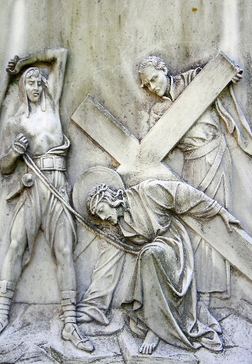
Jesus falls but he gets up again and continues. There are times in life when we fall only to get up and continue. We rise and fall over and over as we attempt to care for the earth, which God has given to us. We fall when we forget or ignore how fragile and connected our world is. We get back up because we bear the responsibility to educate and protect. A never-ending mission. What must I do?

Prayer
Almighty and eternal God, You permitted your Son to be weakened, crushed, and profaned so that He might rise from the dead freed from the ravages of sin. Help us to accept our weaknesses and failings as forerunners of our glorious resurrection in union with your Son. Amen.

Tenth Station
JESUS IS STRIPPED OF HIS GARMENTS
We adore You, O Christ, and we bless You.
Because by your holy Cross You have redeemed the world.

O’Hare Academic Building
So many people are stripped of their dignity, their respect. They live in poverty stripped of dignity and education. We say, “they should do better, they make excuses, they are lazy”. Yet it is prejudice-our prejudice-towards others that strips them of their right to live as God created all of us to live, with dignity. What must I do?

Prayer
Lord Jesus Christ, stripped of everything, You stood exposed to the jeers and contempt of the people whom You loved. Clothe us with genuine love of others, so that nothing we suffer may ever fill our hearts with hatred or bitterness. Amen.

Eleventh Station
JESUS IS NAILED TO THE CROSS
We adore You, O Christ, and we bless You.
Because by your holy Cross You have redeemed the world.

Rose garden
The power of the ocean. The beauty of this gift from God to us. The beauty and the power of human life. The suffering of someone who is different, because of color, customs, language, sexual orientation, state in life. So many people are crucified because of who they are. What must I do?
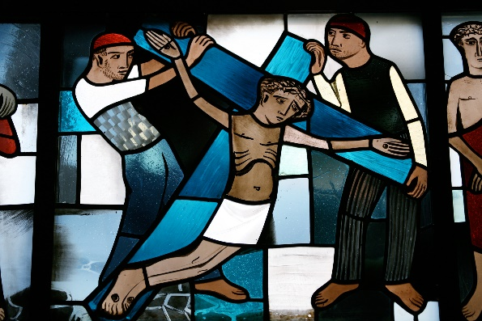
Prayer
Lord and Savior. You have told us that we too must accept crucifixion if we are to accept resurrection with You. Help us to rejoice in the sufferings that come with the fulfillment of our daily duties, seeing in them the royal road of the cross to resurrection. Amen.

Twelfth Station
JESUS DIES
We adore You, O Christ, and we bless You.
Because by your holy Cross You have redeemed the world.

McAuley Hall
LOOK AT THIS BUILDING! ITS BEAUTY!
Think of what went on in this building at the turn of the century. Servants rushing around catering to every whim of the family. Serving the meals, dressing and undressing members of the family. Essential to the running of the house, but not equal. Why? Accidents of birth made them invisible, ‘less valuable” than those who lived there. Who is devalued today? Undocumented, invisible, necessary but not equal, invaders, different? What must I do?

Prayer
Our Father, Who art in heaven,
hallowed be thy name.
Thy kingdom come,
Thy will be done, on earth as it is in heaven.
Give us this day our daily bread
and forgive us our trespasses, as we forgive those who trespass against us,
And lead us not into temptation,
but deliver us from evil. Amen.

Thirteenth Station
JESUS IS TAKEN DOWN FROM THE CROSS
We adore You, O Christ, and we bless You.
Because by your holy Cross You have redeemed the world.

Mary Statue
Black lives matter, the lives given for equality. Rosa Parks, Martin Luther King, Emmett Till, the nameless people who have died for justice. Jesus Christ, love one another. What must I do?

Prayer
Beloved Savior, You returned to the Father all that He had given You, so that He might restore all to You a hundred-fold in the glorious
resurrection. HeIp us, we beg You, to give generously of ourselves in all that we do for You, so that like You we might be made perfect in a new resurrection. Amen.
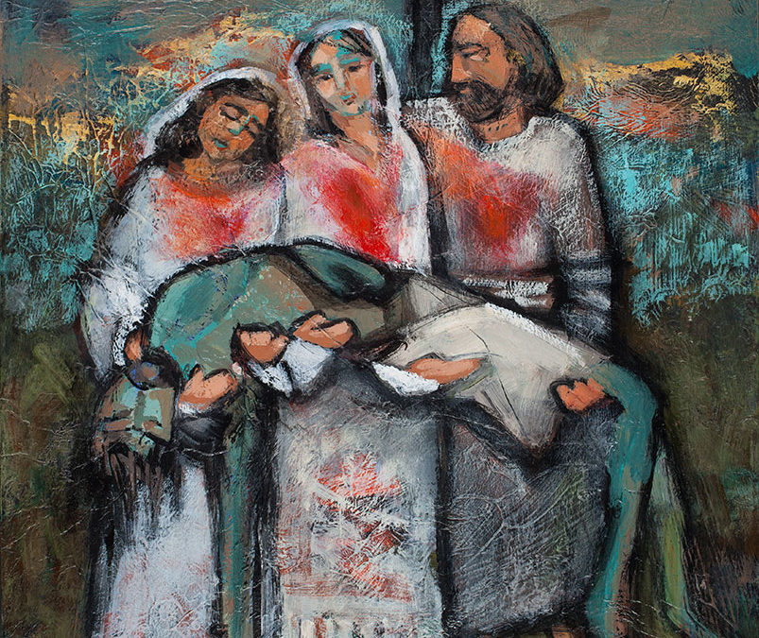

Fourteenth Station
JESUS IS PLACED IN THE TOMB
We adore You, O Christ, and we bless You.
Because by your holy Cross You have redeemed the world.

Chapel
If not me, who? What must I do?

Prayer
Almighty and eternal God, on the edge of sadness when all seemed lost, You restored to us the Savior we thought defeated and conquered. Help
us, we beg You, so to empty ourselves of self-concern that we might see your hand in every failure and your victory in every defeat. These things
we ask in the name of your Son, Jesus Christ, who lives and reigns forever with You in the unity of the Holy Spirit. Amen.
